SEAMANSHIP SEMINAR SERIES
FREQUENTLY ASKED QUESTION
May, 2015
Q: Where do I find detailed information describing the Seamanship Seminar Series and how to use it?
ANS: Information on the Seamanship Seminar Series may be found in Instructor Guide, the Student Guide and in a power point presentation. These aids may be found on the National Public Education web site, or by using this link:
http://wow.uscgaux.info/content.php?unit=e-dept
Highlighted in red, you will see a Just Released headline where the above items may be found and downloaded.
Q: Are there Power Point aids for use when conducting a Seminar?
ANS: Yes there are. The recently revised BS&S power points for each chapter are available and usage is encouraged. They may be found, and downloaded, by using this link:
http://wow.uscgaux.info/content.php?unit=E-DEPT&category=sss
Log in and you will see this page.

Seamanship Seminar Series

Official Manuals, Forms and Documents
Approved by the National E-Department

Title | Last Modified | Download  File Size
Seamanship Seminar Series (All Files) | 30 Jan 15 | 19.4 MB
Boating Safety | 30 Jan 15 | 3.6 MB
Inland Boating | 30 Jan 15 | 4.0 MB
Lines and Knots | 30 Jan 15 | 3.9 MB
Powering Your Boat | 30 Jan 15 | 2.1 MB
Weather and Boating | 30 Jan 15 | 2.6 MB
Your Boat's Radio | 30 Jan 15 | 2.9 MB
Instructor Guide | 30 Jan 15 | 21 KB
Student Guide | 30 Jan 15 | 15 KB

Contact: Division Chief, Course Management for inquiries about the course content
Direct other inquiries to the E- Department Hotline at 1-877-875-6296
These Power Points are new and contain very detailed content.
Q: How do I order codes for my PE seminars?
ANS: Orders may be placed with the Auxiliary Association store using the same procedure we now use for ordering printed books. Here is the step by step procedure:
- Go to the Auxiliary Association web site by clicking this link http://www.shopauxiliary.com/
- Select, from that menu, Auxiliarists Looking for District on line member store
- Sign in
- Select from the left hand Categories listing – Public Education.
- Go to page two and you will see this page

- Click on options and this page will appear.

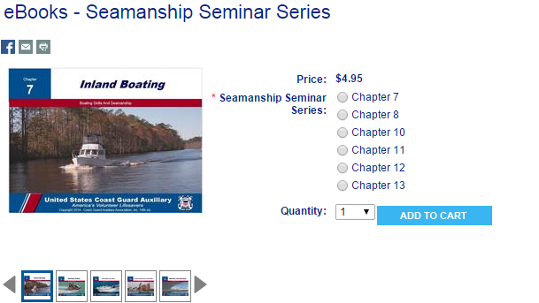

- Select quantity and chapters, then go to checkout. If you have an account use it to order, or
establish one.

Q: Where do I find help with downloading the e-Books from BookShout?
ANS: BookShout has an extensive Knowledge Base that addresses most problems and questions concerning the e-Book download and reading process. The Base is searchable and can be viewed using this link:
http://support.bookshout.com/kb
Q: Do I need to be on line to read an e-Book on my BookShout account?
ANS: To read an e-Book from a PC or Mac, you will need to be online and using your browser. E-Books may be downloaded to other devices, such as an iPad or Kindle Fire, and then read offline.
Q: Can I use the code multiple times to get my e-Book on all my computers and devices?
ANS: Codes may only be used once. However, once the code has been used, and you have established your BookShout account, the e-Book resides in that account and may be read from up to five devices, by opening your BookShout account from that device.
Q: Is there a test for each seminar?
ANS: There is no test for the seminars. No pass/fail. However there are review questions for each seminar, and instructors are encouraged to use them.
Q: Once a seminar is complete how do I enter class data into AUXDATA?
ANS: Use the 7030 form just as you would any PE class. Code the class as BS&S – 14B. Complete the other information such as number of Graduates and those under age 17. Graduates are the number of seminar completers. If more than one seminar/chapter is taught, complete a 7030 for each.
Q: What does the student get, at the seminar end, to attest that they have completed the seminar?
ANS: There is an “Attendance Certificate” template available as a download from the E-Directory web site. The Certificate is in Word so instructors may alter them to reflect which seminars were completed, and to reflect local Flotilla information. The link is:
http://wow.uscgaux.info/content.php?unit=E-DEPT&category=sss

Q: When attempting to redeem a code, a student receives a message, “Bummer! This offer has expired”. How should this be handled?
ANS: It is very likely that the same code was assigned to more than one person. Double check the code assignments. Verify that the hyperlinks with codes assigned are from the correct order. Note that the AUXCEN Inbox shows all orders with the most recent order listed last.

